**Directional wind shear plays some role in the persistence of temperature inversions and signs of slope flows in the lowest levels.**

Short (5 minutes – 1 hour) inversions account for the most frequent types of inversions recorded. They also display the highest variability in wind direction and directional wind shear. Plots in Figure 1 display directional wind between sensors at 10 meters and 1.5 meters (a-d), and sensors at 10 meters and 0.2 meters (e-h). A perfect directional relationship with connected flow would align with the diagonal dotted line, and most inversions fall along or near this line. However, the short inversions (<= 1hour) tend to separate from this pattern, showing a slightly larger variance, suggesting that longer-lasting inversions form better with winds that align vertically (connected flow).

In addition to directional shear, all locations exhibited a disposition for more persistent inversions when winds originated from the southeast, south, or west, at 10 meters and near the surface. The main gully ran from west to east. The plots of 10 meters vs 1.5 meters in Figure 1 fail to show groupings along the gully axis, suggesting deep flow up or down-gully was not a driver of persistent inversions. However, the plots of 10 meters vs 0.2 meters show clusters of wind near the surface from the east and west at the Init, Rel, and Lconv sites, suggesting slope flows were restricted to the lowest meter along the surface and indicators for inversion development.

The plots for the uconv site at 0.2 meters (fig 1c) and 1.5 meters (fig 1g) looked very similar to each other. Uconv was located at the convergence of two gullies. The main gully is oriented west-east, and the other is oriented north-south. If slope flow was a factor, we should expect to see some periods where flow from the north drains down to the sensor. This could be getting averaged out because the main gully is more prominent, or there could be some type of circulation that these plots are not capturing.

Another prominent feature is that persistent inversions failed to develop from a north wind. A further analysis would be necessary on the local features located in each cardinal direction.

As we move closer to the surface in Figure 1 (e-f), plots with wind direction at 10 meters and 0.2 meters show winds becoming slightly more disconnected from winds from aloft. Surface-induced drag is likely a key driver for the turning of the winds. This should be compared to non-inversion conditions.

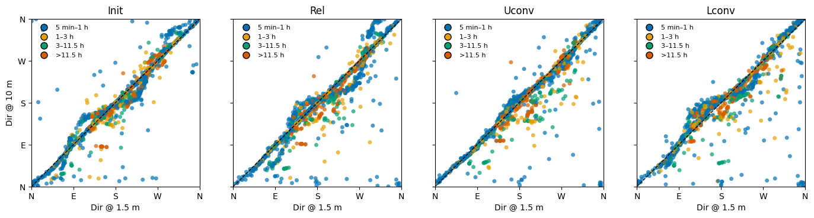

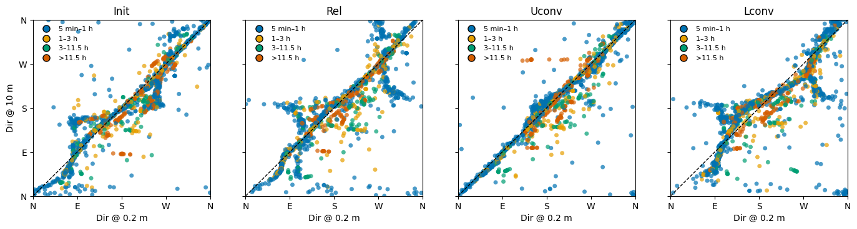

Next steps:

This analysis does not account for magnitude. The next step for me would be subsetting the data into bins based on wind speed. Additionally, this does not account for vegetation effects (surface roughness). By looking at pre- and post-harvest and identifying what structures and features exist, we could see if vegetation plays any role. An additional look at topography would help, as well. The slope to the north of the towers was slightly gentler than the slope to the south. I also want to look into inversion strength and these wind directions.